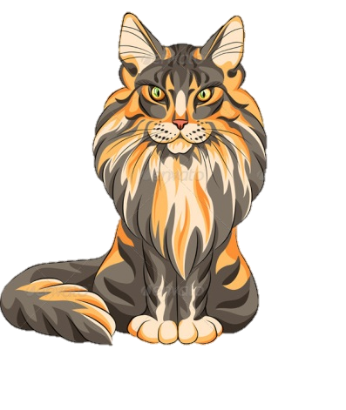

**CAT STORES INCORPORATED PRESENTS…**

APCS End of Year Project

**The Ultimate Cat Store Database**

**A Complete Inventory**

**By Phillip Yu, Hannah Huang, and Caroline Gao**